A Project Report On



**Aj Coding**

Developed At **Harivandana College**

For the fulfilment of the requirements for the

## B.C.A. – 6th Semester[2021]

**Developed By**

**Jasani Abhi**

Submitted To



**DEPARTMENT OF COMPUTER SCIENCE**

## -: Under the Guidance of :-

### Dr. Ashwin Rathod (Head Of Department) Prof. Dharmendra Ambani (Project In-charge)



**CERTIFICATE**

This is to certify that the project report entitled AJ Coding submitted to Harivandana College Rajkot, in partial fulfilment of the requirement for the Current Semester B.C.A SEM VI - 2021, work carried out by Jasani Abhi .

The project process is carried during the present semester in computer laboratories under the supervision of a guide preferably from the college. During this semester, the student has gone through several theoretical reports such as SDLC, Database Management System, S/W Engineering etc. The matter embodied in this project is satisfactory done by the student for the fulfilment of the required semester.

Head of Department Internal Guide

Dr.Ashwin Rathod Prof.Dharmendra Ambani



**ABSTRACT**

* Android is a software stack for mobile devices that includes an operating system, middleware and key applications. Android is a software platform and operating system for mobile devices based on the Linux operating system and developed by Google and the Open Handset Alliance. It allows developers to write managed code in a Java-like language that utilizes Google-developed Java libraries but does not support programs developed in native code.
* The unveiling of the Android platform on 5 November 2007 was announced with the founding of the Open Handset Alliance, a consortium of 34 hardware, software and telecom companies devoted to advancing open standards for mobile devices. When released in 2008, most of the Android platform will be made available under the Apache free-software and open-source license.



# INDEX

|  |  |  |
| --- | --- | --- |
| **No** | **Subject Title** | **Page No.** |
| **\*** | **Acknowledgement** | 01 |
| **\*** | **Abstract** | 02 |
| **\*** | **Index** | 03 To 04 |
| **\*** | **Student information** | 05 |
| **\*** | **Project profile** | 06 |
| **1** | **Introduction**   * 1. **The Birth of Android**      1. **Google Acquires Android Inc.**      2. **Open Handset Alliance Founded**      3. **Hardware**   2. **FEATURES**      1. **Application Framework**      2. **Dalvik Virtual Machine**      3. **Integrated Browser**      4. **SQLite**      5. **Data Storage**      6. **Web Browser**      7. **Java Virtual Machine**      8. **Additional Hardware Support**      9. **Development Environment** | 7 To 10 |
| **2** | **Literature survey** | 11 To 15 |



|  |  |  |
| --- | --- | --- |
| **3** | **Project Management**  **3.1 Project Planning and Scheduling** | 16 To 17 |
| **4** | **Requirement & Specification**   * 1. **Hardware Requirements**   2. **Software Requirements** | 18 |
| **5** | **System Design**   * 1. **Use Case Diagram**   2. **Context Level Diagram** | 19 To 20 |
| **6** | **Implementation**   * 1. **Environment Setting**   2. **Program module specification** | 21 To 22 |
| **7** | **Testing**   * 1. **Testing**   2. **Testing Levels**   3. **Types of Testing**   4. **Test Cases Based on Implementation**   5. **White Box Testing** | 26 To 30 |
| **8** | **Screen Shot** | 31 To 35 |
| **9** | **Future Work** | 36 |
| **10** | **Conclusion** | 37 |
| **11** | **Bibliography** | 38 |



**STUDENT INFORMATION**

* + **Enrollment No.:** 00310318527
  + **Name:** Jasani Abhi
  + **Address:** To.Rajkot

Ta: Rajkot

Dist: Rajkot

* + **Mobile No:** +91 9737579748
  + **E-mail:** abhijasani7@gmail.com

**PROJECT PROFILE**



* + **Project Title:** Aj Coding
  + **Platform:** Android Mobiles
  + **Client Side:** Any Network
  + **Technology:** Android, Java
  + **Front End:** Android studio
  + **Back End:** phpmyadmin
  + **Documentation Tool:** Microsoft Word
  + **Period of Project Working:** 3 Months
  + **Developed By:** Jasani Abhi
  + **Submitted To:** Saurashtra University

1. **INTRODUCTION**



Android is a software stack for mobile devices that includes an operating system, middleware and key applications. Android is a software platform and operating system for mobile devices based on the Linux operating system and developed by Google and the Open Handset Alliance. It allows developers to write managed code in a Java-like language that utilizes Google-developed Java libraries but does not support programs developed in native code.

The unveiling of the Android platform on 5 November 2007 was announced with the founding of the Open Handset Alliance, a consortium of 34 hardware, software and telecom companies devoted to advancing open standards for mobile devices. When released in 2008, most of the Android platform will be made available under the Apache free-software and open-source license.

* 1. **THE BRITH OF ANDROID**
     1. **Google Acquires Android Inc.**

In July 2005, Google acquired Android Inc., a small startup company based in Palo Alto, CA. Android's co-founders who went to work at Google included Andy Rubin (co-founder of Dangar), Rich Miner (co-founder of Wildfire Communications, Inc), Nick Sears (once VP at T-Mobile), and Chris White (one of the first engineers at WebTV). At the time, little was known about the functions of Android Inc. other than they made software for mobile phones.

At Google, the team, led by Rubin, developed Linux-based mobile devices which they marketed to handset makers and carriers on the premise of providing flexible, upgradeable system. It was reported that Google had already lined up a series of hardware component and software partners and signalled to carriers that it was open to various degrees of cooperation on their part.



* + 1. **Open Handset Alliance Founded**

On 5 November 2007, the Open Handset Alliance, a consortium of several companies which include Google, HTC, Intel, Motorola, Qualcomm, T-Mobile, Sprint Nextel and NVIDIA, was unveiled with the goal to develop open standards for mobile devices. Along with the formation of the Open Handset Alliance, the OHA also unveiled their first product, Android, an open source mobile device platform based on the Linux operating system.

#### Hardware

Google has unveiled at least three prototypes for Android, at the Mobile World Congress on February 12, 2008. One prototype at the ARM booth displayed several basic Google applications. I-pad control zooming of items in the dock with relatively quick response.

#### FEATURES:

* + 1. **Application Framework**

It is used to write applications for Android. Unlike other embedded mobile environments, Android applications are all equal, for instance, an application which come with the phone are no different than those that any developer writes. The framework is supported by numerous open source libraries such aspens’, MySQL and lib cs. It is also supported by the Android core libraries. From the point of security,

#### Dalvik Virtual Machine

It is extremely low-memory based virtual machine, which was designed especially for Android to run on embedded systems and work well in low power situations. It is also tuned to the CPU attributes. The Dalvik VM creates a special file format (. DEX) that is created through build time post processing. Conversion between Java classes and. DEX format is done by included “dx” tool.



* + 1. **Integrated Browser**

Google made a right choice on choosing Web Kit as open source web browser. They added a two-pass layout and frame flattening. Two pass layout loads a page without waiting for blocking elements, such as external CSS or external JavaScript and after a while renders again with all resources downloaded to the device. Frame flattening converts founded frames into single one and loads into the browser. These features increase speed and usability browsing the internet via mobile phone.

#### MySQL

MySQL is a freely available open source Relational Database Management System (RDBMS) that uses Structured Query Language (**SQL**). **SQL** is the most popular language for adding, accessing and managing content in a database. It is most noted for its quick processing, proven reliability, ease and flexibility of use.

#### Data Storage

MySQL is used for structured data storage. the most popular Open Source SQL database management system, is developed, distributed, and supported by Oracle Corporation

#### Web Browser

The web browser available in Android is based on the open-source Web Kit application framework. It includes Lowborn which is a modern web browser engine which powers both the Android browser and an embeddable web view.



* + 1. **Java Virtual Machine**

Software written in Java can be compiled into Dalvik byte codes and executed in the Dalvik virtual machine, which is a specialized VM implementation designed for mobile device use, although not technically a standard Java Virtual Machine.

#### Additional Hardware Support

Android is fully capable of utilizing video/still cameras, touch screens, GPS, compasses, accelerometers, and accelerated 3D graphics.

#### Development Environment

Includes a device emulator, tools for debugging, memory and performance profiling, and a plug-in for the Eclipse IDE. There are a number of hardware dependent features, for instance, a huge media and connections support, GPS, improved support for Camera and simply GSM telephony. A great work was done for the developers to start work with Android using device emulator, tools for debugging and plug-in for Eclipse IDE.



1. **LITERATURE SURVEY**

**PHP/MySQL**

* **What is MySQL?**

**PHP + MySQL**

* MySQL is a database system used on the web.
* MySQL is a database system that runs on a server.
* MySQL is ideal for both small and large applications.
* MySQL is very fast, reliable, and easy to use.
* MySQL supports standard SQL.
* MySQL compiles on a number of platforms.
* MySQL is free to download and use.
* MySQL is developed, distributed, and supported by Oracle Corporation.
* The data in MySQL is stored in tables. A table is a collection of related data, and it consists of columns and rows. Databases are useful when storing information categorically. A company may have a database with the following.



**What is PHP?**

**PHP** is a server-side scripting language designed for web development but also used as a general-purpose programming language. PHP is now installed on more than 244 million websites and 2.1 million web servers. Originally created by Rasmus Leadoff in 1995, the reference implementation of PHP is now produced by The PHP Group. While

PHP code is interpreted by a web server with a PHP processor module which generates the resulting web page: PHP commands can be embedded directly into an HTML source document rather than calling an external file to process data. It has also evolved to include a command-line interface capability and can be used in standalone graphical applications.

PHP originally stood for *Personal Home Page*, it is now said to stand for *PHP: Hypertext Preprocessor*, a recursive acronym.

#### What is a PHP File?

* PHP files can contain text, HTML, JavaScript code, and PHP code.
* PHP code is executed on the server, and the result is returned to the browser as plain HTML.
* PHP files have a default file extension of ".php" .

#### What Can PHP Do?

* PHP can generate dynamic page content.
* PHP can create, open, read, write, and close files on the server.
* PHP can collect form data.
* PHP can send and receive cookies.
* PHP can add, delete, and modify data in your database.
* PHP can restrict users to access some pages on your website.
* PHP can encrypt data.



**Why PHP?**

* PHP runs on different platforms (Windows, Linux, UNIX, Mac OS X, etc.).
* PHP is compatible with almost all servers used today (Apache, IIS, etc.).
* PHP has support for a wide range of databases.
* PHP is free. Download it from the official PHP resource: [www.php.net.](http://www.php.net/)
* PHP is easy to learn and runs efficiently on the server side.

#### Advantages of MySQL

* + Some of its advantages include the following:
  + **It's easy to use**: While a basic knowledge of SQL is required—and most relational databases require the same knowledge—MySQL is very easy to use. With only a few simple SQL statements, you can build and interact with MySQL.
  + **It's secure**: MySQL includes solid data security layers that protect sensitive data from intruders. Rights can be set to allow some or all privileges to individuals. Passwords are encrypted.
  + **It's inexpensive**: MySQL is included for free with NetWare® 6.5 and available by free download from MySQL Web site.
  + **It's fast**: In the interest of speed, MySQL designers made the decision to offer fewer features than other major database competitors, such as Sybase* and Oracle*. However, despite having fewer features than the other commercial database products, MySQL still offers all of the features required by most database developers.
  + **It's scalable**: MySQL can handle almost any amount of data, up to as much as 50 million rows or more. The default file size limit is about 4 GB. However, you can increase this number to a theoretical limit of 8 TB of data.
  + **It manages memory very well**: MySQL server has been thoroughly tested to prevent memory leaks.



* + **It runs on many operating systems**: MySQL runs on many operating systems, including Novell NetWare, Windows* Linux*, many varieties of UNIX* (such as Sun* Solaris*, AIX, and DEC* UNIX), OS/2, FreeBSD*, and others.
  + **It supports several development interfaces**: Development interfaces include JDBC, ODBC, and scripting (PHP and Perl), letting you create database solutions that run not only in your NetWare 6.5 environment, but across all major platforms, including Linux, UNIX, and Windows.



# PROJECT MANAGEMENT

#### Project Planning and Scheduling

##### Project development Model

* **Software Development Process: Waterfall Model**

In the waterfall model, a project progresses through an orderly sequence of steps from the initial software concept through system testing. The project holds a review at the end of each phase to determine whether it is ready to advance to the next phase - from requirements analysis to architectural design. If the review determines that the project isn't ready to move to the next phase, it stays in the current phase until it is ready.

The waterfall model is document driven, which means that the main work products that are carried from phase to phase are documents. In the pure waterfall model, the phases are also discontinuous - they do not overlap. The following shows how the pure waterfall lifecycle model progresses.

The pure waterfall model performs well for product cycles in which you have a stable product definition and when you're working with well-understood technical methodologies. In such cases, the waterfall model helps you to find errors in the early, low-cost stages of a project. It provides the requirement stability that developers crave. If you're building a well-defined maintenance release of an existing product or porting an existing product to a new plat. Form, a waterfall lifecycle might be the right choice for rapid development.

The pure waterfall model helps to minimize planning overhead because you can do all the planning up front. It doesn't provide tangible results in the form of software until the end of the lifecycle, but to someone who is familiar with it, the documentation it generates provides meaningful progress throughout the lifecycle.



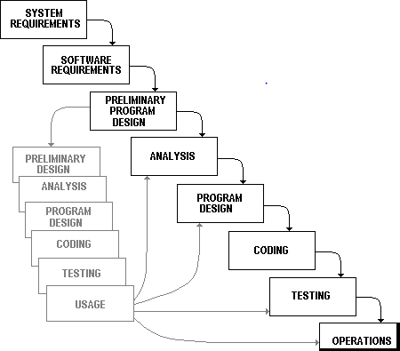

The waterfall model works well for projects that are well understood hut complex, because you can benefit from tackling complexity in an orderly way. It works well when quality requirements dominate cost and schedule requirements. Elimination of midstream changes eliminates a huge and common source of potential errors.

|  |  |
| --- | --- |
| **Risk Items** | **Risk Management Techniques** |
| Personnel shortfalls | Staffing with top talent; team building; cross-  training; pre-scheduling key people |
| Unrealistic schedules and  Budgets | Detailed multi-source cost & schedule estimation;  incremental development; reuse |
| Developing the wrong  software functions | User-surveys; prototyping; early users’ manuals |



# REQUIREMENTS

**& SPECIFICATION**

#### 4.1 HARDWARE REQUIREMENTS

* + - 2.5GHz dual-core Intel Core i5
    - 4 GB memory
    - 160 GB hard drive
    - Intel HD Graphics 4000
    - OS Windows Platform

#### 4.2 SOFTWARE REQUIREMENTS

##### Programming Technology used

* Tool: code
* Platform: Android Studio
* Front-End: Android

#### Operating System

Name: Android

1. **SYSTEM DESIGN**



Select Lang.



View Defi.



* 1. **Use Case Diagram**



User

Open App

Home

View Lang.



Select Defi.

Close App

View Prog.

View Album

Exit



**5.2. Context Level Diagram**



user

Exit

Click

View Program And Output

View Program List

Enable Dark Mode

Share

Show Language



1. **IMPLEMENTATION**
   1. **Environment Setting:**

In this project the implementation environment is Multi-User Environmental the developers of the project are working on Team Explorer. The latest version of the project can be accessed by any developer at any time. The environment is GUI-based as the project is developed in PHP.

* + - Multiple users can be used.
    - Uniform GUI Design
    - SQL server name and authentication required for normal/network base accessory.
    - Internet support

##### Implementation Planning:

Implementation phase requires precise planning and monitoring mechanism in order to ensure schedule and completeness. We developed the website in various sub phases.

in Implementation Phase. These steps are as follows:

##### Database Implementation:

This phase involved creation of database table and specifying relationships among them in MySQL.

##### Core Class Implementation:

First, we decided to implement the core system classes which will facilitate the further implementation.



##### User Components Implementation:

Motive behind this separate phase is to focus on the Reusability. In these phases we have tried to developed reusable user interface components.

#### Program module specification

##### User

* + Can see all Language name.
  + Can Select Any Language.
  + User can see All Definition List.
  + User can Select Any Program And View Full Program And It’s Output.



1. **TESTING**



* 1. **TESTING**

*Testing* is one of the important steps in system development. Software Testing also provides an objective, independent view of the software to allow the business to appreciate and understand the risks at implementation of the software. Test techniques include, but are not limited to, the process of executing a program or application with the intent of finding software bugs.

Software Testing can also be stated as the process of validating and verifying that a software program/application/product:

1. Meets the business and technical requirements that guided its design and development;
2. Works as expected; and
3. Can be implemented with the same characteristics.

Software Testing, depending on the testing method employed can be implemented at any time in the development process. However, most of the test effort occurs after the requirements have been defined and the coding process has been completed. As such, the methodology of the test is governed by the Software Development methodology adopted.



* 1. **TESTING LEVELS**

Tests are frequently grouped by where they are added in the software development process, or by the level of specificity of the test.

##### Unit Testing

*Unit Testing* refers to tests that verify the functionality of a specific section of code, usually at the function level. In an object-oriented environment, this is usually at the class level, and the minimal unit tests include the constructors and destructors.

These types of tests are usually written by developers as they work on code (white-box style), to ensure that the specific function is working as expected. One function might have multiple tests, to catch corner cases or other branches in the code. Unit testing alone cannot verify the functionality of a piece of software, but rather is used to assure that the building blocks the software uses work independently of each other. Unit testing is also called *Component Testing.*

##### System Testing

System Testing tests a completely integrated system to verify that it meets its requirements.



* 1. **TYPES OF TESTING**

##### Functional Testing

It is an approach to testing where the tests are derived from the program or component specification. The system is a black box whose behavior can only be determined by studying its inputs and the related outputs.

##### Structural Testing

Structural testing is an approach to testing where the tests are derived from knowledge of the software ‘s structure and implementation. This approach is sometimes called ‗white-box testing’ to distinguish from black –box testing.



* 1. **TEST CASES BASED ON IMPLEMENTATION**

The tables following give the number of test cases, which are implemented for invoking testing the project. The table comprises of

1. Test case ID
2. Description
3. Input/Server Controls
4. Results/Outputs
5. Pass

The test case ID gives a unique number identifying the test for each case.

Description describes about the nature of that test. Input is the control that.

**Client Needs Acceptance Testing**

### Requirements System Testing

### Design Integration Testing

**Code Unit Testing**



**Unit Testing**



**Module**



**Testing**

**Subsystem**



## Testing

**System**



## Testing

**Acceptance**

## Testing

#### 7.5) White Box Testing

This type of testing ensures that

* All independent paths have been exercised at least once
* All logical decisions have been exercised on their true and false sides
* All loops are executed at their boundaries and within their operational bounds
* All internal data structures have been exercised to assure their validity
* To follow the concept of white box testing we have tested each form we have created independently to verify that Data flow is correct, all conditions are exercised to check their validity, all loops are executed on their boundaries.

1. **SCREEN SHOT**



**8.1) Android Application**

* **Splash Screen :**
  + 1. 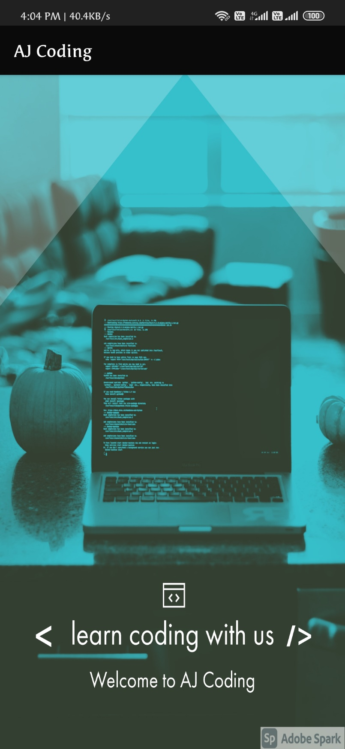

**Main Activity:**



**Show All Language Name :**

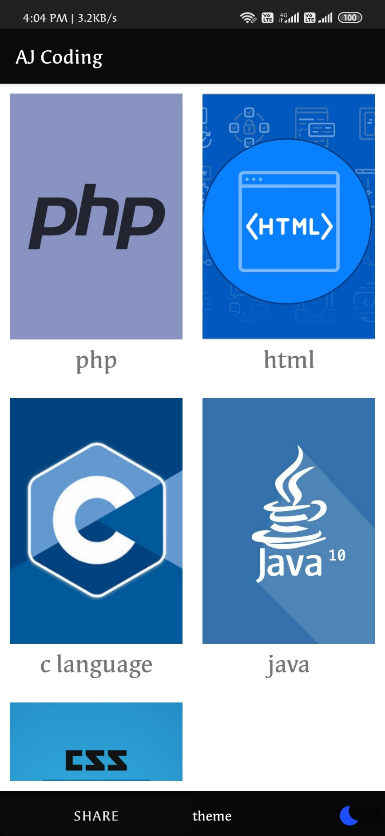



* + 1. **Dark Mode :**
    2. 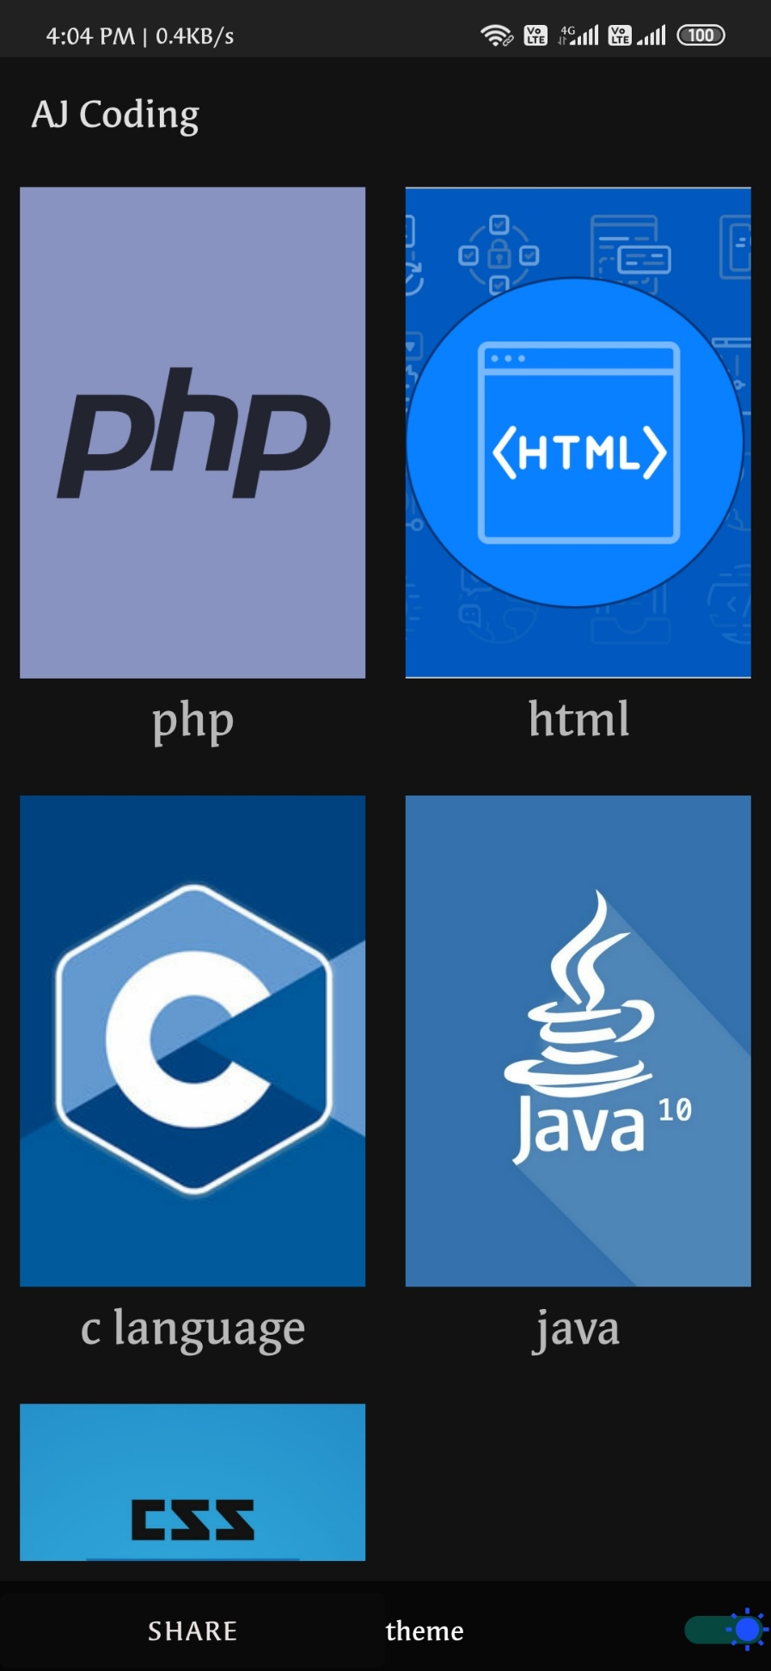
    3. **Sub Activity(Program List):**



* + 1. 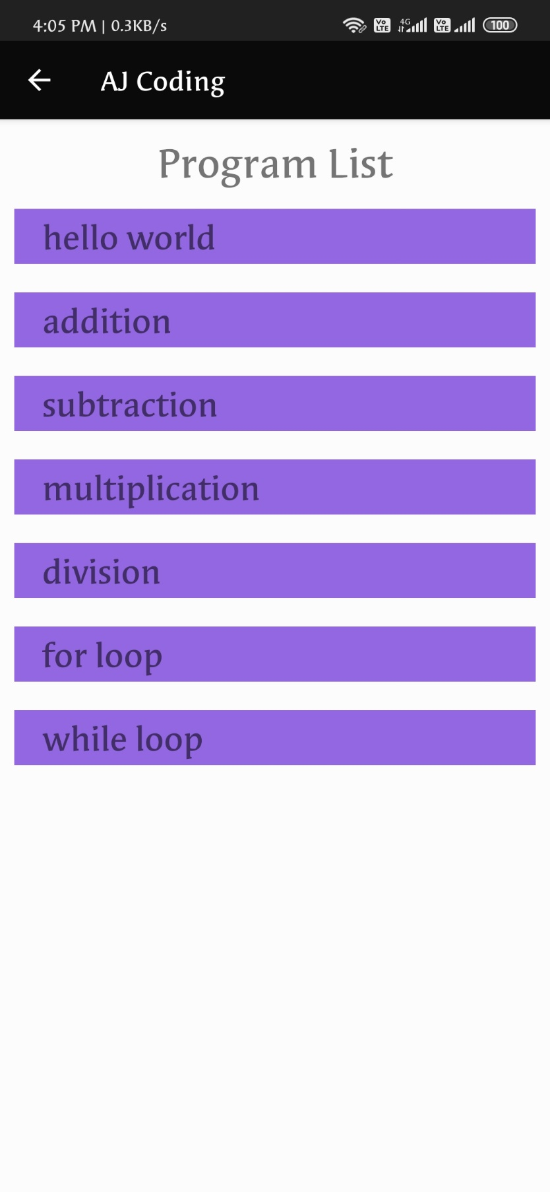
    3. **Program And Output Activity:**



* + 1. 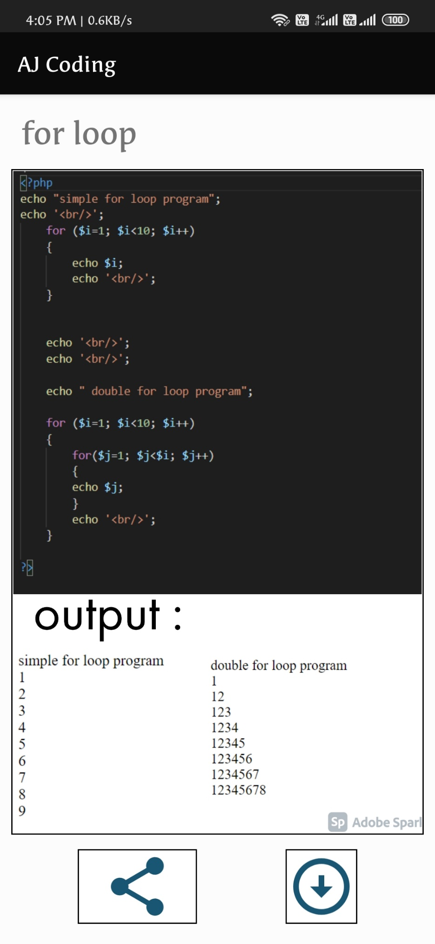



1. **FUTURE WORK**



* We have done analysis of this entire system till now, and in future we will develop this system as per our analysis.
* In future this application will became very user-friendly.
* We will covert this web-site into online management so that any user can access our web-site anywhere through their mobiles.



**10. CONCLUSION**

The Application is designed to be very user-friendly and interactive manner so that the user cannot find any difficulty while browsing the Application. Thereby the proposed Application, which is an economically, technically and operationally feasible system has overcome the deficiency that was present in the manual system. It emphasizes the importance of timeliness and accuracy that is acquired through automated software.



# 11.BIBLIOGRAPHI

Following are the books we referred during the development, coding and documentation phase of the project work.

* A PHP5 and MySQL Bible.
* HTML & DHTML in 21 Days.
* Work Professional Java Script for Web.
* Learning web Design 4th edition
* HTML 10step or less

##### Web Reference

* + 1. [http://stackoverflow.com](http://stackoverflow.com/)
    2. [http://php.net](http://php.net/)
    3. http://www.youtube.com